Final Year Project Proposal

Department of Software Engineering
N.E.D University of Engineering and Technology

OBEaaS
Outcome Based Education as a Service

Aqib Mukhtar
SE-056

Abdul Rehman
SE-050

Muhammad Uzair
SE-052

- Motivation

The purpose of OBEaaS is to provide an integrable microservice that aims to digitally transform the OBE system, currently applied in NED University. It aims to provide a digitalized approach for the process of assigning marks and maintaining the academic records of students on the basis of Outcome Based Education System. The motivation behind this project is to reduce the efforts the teachers have to make in handling the students’ records manually by providing them a user-friendly environment through which they can easily manage academic records of students and also generate relevant reports. It also aims to provide the students a platform where they can see their assigned marks of each CLO (Course Learning Outcome) assisted using an assessment tool by the course teacher.

- Overview
  - Significance/Importance of project
In order to get accreditation from Pakistan Engineering Council (PEC), Software Engineering Department of NED University is required to follow OBE system. In OBE system a complete record of students’ performance in all of the CLOs has to be maintained and the information of the CLOs itself has to be defined as well. Manually handling the records about students’ assessments and information about CLOs requires so much effort from teachers. OBEaaS will reduce these efforts as it will be managing the data for them while also providing a PEC and HEC compliant product following all of their rules and standards regarding OBE.

Currently, such a platform is not available where all the teachers could adopt a uniform approach in maintaining data related to OBE system. This problem causes difficulties for the teachers as there is no uniform and well-defined approach, so teachers are required to manage all the data themselves. Through OBEaaS it will be easy for the teachers to follow a uniform approach because the report generated by the product will also have the same format.

In the era of digital transformation, Human work is being reduced with the help of software, paperwork is being replaced by centralized databases. Digital transformation increases the efficiency of performing a task and also provides high accuracy in performing a task. OBEaaS will be another step towards digital transformation at NED University as it will be providing a software-based solution for the management of assessment of the students on the basis of OBE system.

  - Description of project
It aims to provide a digitalized approach for the process of assigning marks and maintaining the academic records of the students on the guidelines of the OBE system.

At the moment no such platform is available where teachers can adopt a uniform approach in managing data related to OBE, it will generate a report of the students’ records that contain the organized data of student’s progress in a semester and, in that way, uniformity can be achieved.

The idea behind the project is to manage the workload of teachers and also facilitate students to get real-time feedback upon assessments i.e. students can easily check their progress on assessment and CLO basis.

The scope of our work is specific i.e. to provide digitalization. OBEaaS is a service that allows users to manage the amount of work in an organized and uniform way. Our specific approach can also be transformed into a generalized approach that we can also integrate our service with the already existing portals in the universities.

  - Background of project
Information about certain term and definitions was provided by Software Engineering Department of NED University.
i. Program Educational Objectives (PEOs):
Program Educations Objectives describe the career and professional accomplishments that programs are preparing graduates to attain within a few years of education
Example:
- PEO-1: Demonstrate necessary knowledge and skills in Software Engineering profession.
- PEO-2: Work and communicate effectively in team.
- PEO-3: Undertake professional practice considering ethical, societal and environmental implications.
- PEO-4: Be engaged in lifelong learning and continued professional growth.

ii. Program Learning Outcomes (PLOs):
PLOs are graduate attributes or skills that the student should have after the completion of degree. There are 12 PLOs in OBE system:

- Engineering Knowledge
- Problem Analysis
- Design/Development of Solutions
- Investigation
- Modern Tool Usage
- The Engineer and Society
- Environment and Sustainability
- Ethics
- Individual and Team Work
- Communication
- Project Management
- Lifelong Learning
iii. Mapping of PLOs on PEOs:
One or more than one PLOs are required to achieve a PEO. One PLO can be mapped on only one PEO

PLOs | PEO-1 | PEO-2 | PEO-3 | PEO-4
Engineering Knowledge | X
Problem Analysis | X
Design/Development of Solutions | X
Investigation | X
Modern Tool Usage | X
The Engineer and Society |  |  | X
Environment and Sustainability |  |  | X
Ethics |  |  | X
Individual and Team Work |  | X
Communication |  | X
Project Management |  | X
Lifelong Learning |  |  |  | X

iv. Course Learning Outcomes (CLOs):
CLOs are the skills that a student should have after the completion of a particular course. These CLOs can be of different domains these domains are defined by Bloom’s Taxonomy.

v. Bloom’s Taxonomy:
Bloom’s Taxonomy employs three distinct domains which are described as follows:

- The cognitive domain includes those objectives that deal with the recall or recognition of knowledge and the development of intellectual abilities and skills.
- The affective domain includes objectives that describe changes in interest, attitudes, and values
- The psychomotor domain includes the manipulative or motor-skill area.
These domains can further have different levels.
Example:
A CLO of Cognitive domain of level 3 will be written as C-3

vi. Mapping of CLO on PLOs:
More than one CLOs are required to achieve a PLO.

CLO DESCRIPTION | TAXONOMY LEVEL | PLO | ASSESSMENT TOOL
Apply concept and skills for Effort Estimation of software projects | C-3 | Engineering Knowledge | Assignment-1
Carry out project feasibility study and budget estimation | C-2 | Problem analysis, Investigation | Mid question-1
Discuss concepts related to Object Oriented Programming | C-3 | Engineering knowledge, Project management | Quiz question-3

- Salient Features
The salient features that OBEaaS will provide are:
- Manage the workload of teachers
By using OBEaaS the teachers can do the following activities:
  - Define new CLOs, also can edit already existing CLOs
  - Define new assessment tools for a particular CLO
  - Map CLOs on a particular PLO
  - Assign a particular taxonomy level to a particular CLO
  - Generate a report of the academic record of the students

- Real-time feedback upon assessment
The student will get the following benefit:
- Check the assessment methods
- Check the marks of every course
- Check the marks of each CLOs of a particular course
- Check the overall progress in a semester

- Project Planning
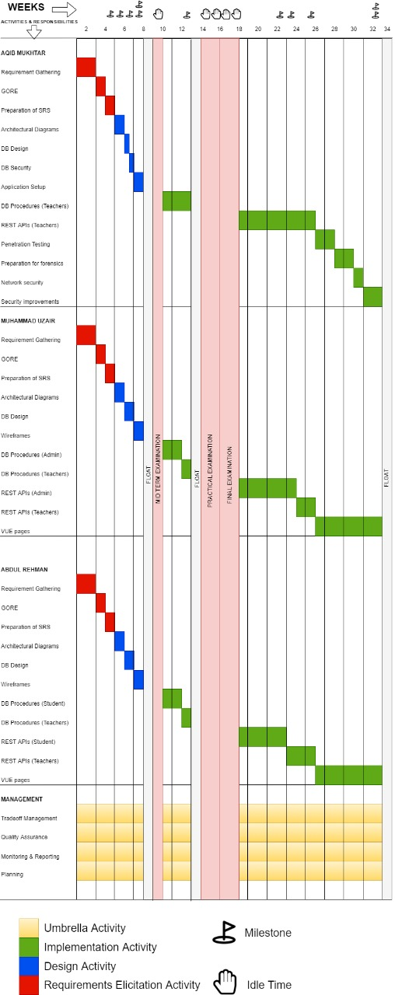
Sr. no | Week | Milestone Name | Description
1 | 4 | SRS | Software Requirement Specification. A document listing all the requirements to be met by OBEaaS.
2 | 5 | Architectural Diagrams | Different diagrams showing the conceptual representation of the OBEaaS by using UML (Unified Modeling Language), conforming SRS.
3 | 6 | ERD | Entity Relationship Diagram. A diagram showing conceptual representation of the database, conforming SRS.
4 | 7 | Application Structure | A physical organization of directories and files showing how OBEaaS will be structured, conforming Architectural Diagrams.
5 | 7 | Wireframes | Front end prototypes visualizing SRS
6 | 12 | DB Procedures | Procedures defined in physical database ensuring all services to be provided by database.
7 | 22 | Student REST APIs | REST APIs ensuring all services to be used by students.
8 | 23 | Admin REST APIs | REST APIs ensuring all services to be used by admin.
9 | 25 | Teacher REST APIs | REST APIs ensuring all services to be used by teachers.
10 | 32 | Security Report | A report mentioning all the information related to the cyber security of the OBEaaS.
11 | 32 | GUI | Graphical User Interface. An interactive interface to make users easily get benefit from OBEaaS.

- Required Hardware and Software
Only a single server machine is required inside NEDs premises, connected to LAN. Rest of the network Infrastructure is already present and will be utilized as is. The estimates for server’s resource consumptions will be made during design phase. The software requirements are tabled below:
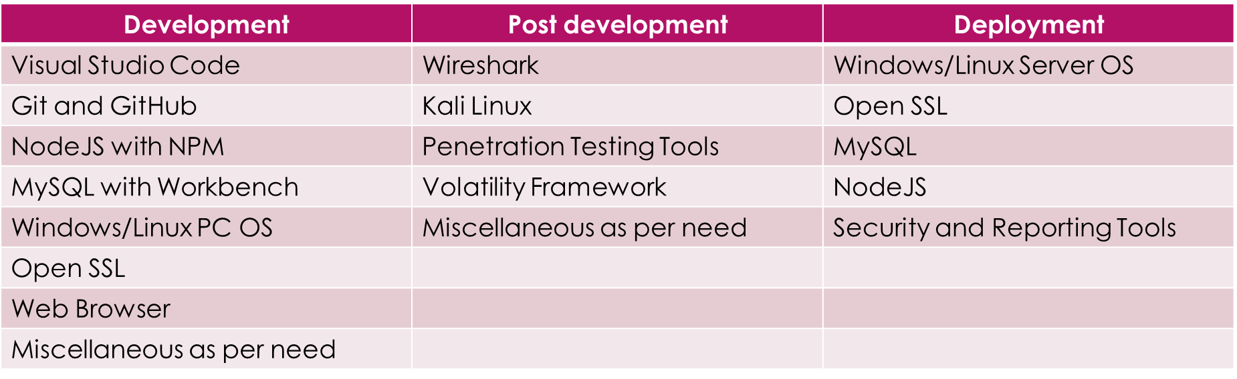
- Letters/Recommendations
Not applicable.
- Diagrammatic Representation of the Overall System
The entire system is divided into three parts(layers). Each layer has unique responsibilities to be fulfilled. The functionalities of the layers will not intercept each other. The layers are named on the basis of the functionality they provide namely, Presentation Layer, Business Layer, and Data Access Layer.
The Data Access layer represents the database model. It will contain the DB structure which includes relationships, datatypes, association, aggregation, composition, etc. The procedures will be written to avoid the direct calling of SQL queries from the Controller layer.
Presentation Layer contains template for all the pages to be dynamically rendered at the server. The dynamic data may come from the Data Access Layer. Each template will be served on the demand of the client (browser). These templates will be used to provide HTML pages to client browsers.
The Business Layer is the sandwich between the Data Access Layer and Presentation Layer. There is no direct connection between Data Access Layer and Presentation but to pass from Business Layer. It will control data flow, filtering, validation & verification, calling DB procedures, and rendering correct views. It is responsible to implement all business logic and drivers.
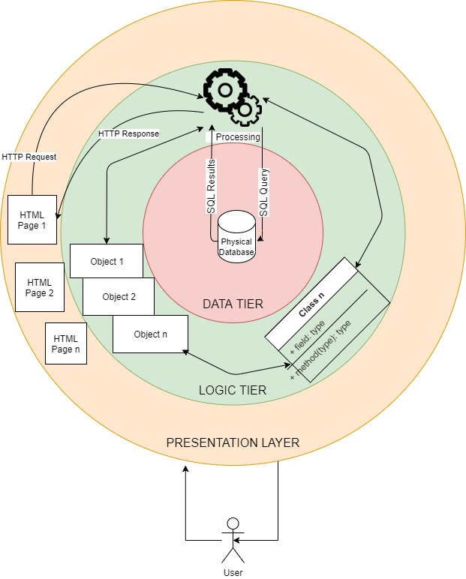

- References
[1]"Download Windows Server 2008 Standard from Official Microsoft Download Center", Microsoft.com, 2020. [Online]. Available: https://www.microsoft.com/en-pk/download/details.aspx?id=5023. [Accessed: 25- Oct- 2020].
[2]"Node.js", Node.js, 2020. [Online]. Available: https://nodejs.org/en/. [Accessed: 25- Oct- 2020].
[3]"npm | build amazing things", Npmjs.com, 2020. [Online]. Available: https://www.npmjs.com/. [Accessed: 25- Oct- 2020].
[4]"MySQL", Mysql.com, 2020. [Online]. Available: https://www.mysql.com/. [Accessed: 25- Oct- 2020].
[5]"Overview | NEDUET Software Engineering Department Website", Se.neduet.edu.pk, 2020. [Online]. Available: https://se.neduet.edu.pk/. [Accessed: 25- Oct- 2020].
[6]"Multitier architecture", En.wikipedia.org, 2020. [Online]. Available: https://en.wikipedia.org/wiki/Multitier_architecture. [Accessed: 25- Oct- 2020].
[7]"Microservices", En.wikipedia.org, 2020. [Online]. Available: https://en.wikipedia.org/wiki/Microservices#:~:text=Microservice%20architecture%20%E2%80%93%20a%20variant%20of,and%20the%20protocols%20are%20lightweight. [Accessed: 25- Oct- 2020].
[8]"Oracle VM VirtualBox", Virtualbox.org, 2020. [Online]. Available: https://www.virtualbox.org/. [Accessed: 25- Oct- 2020].

